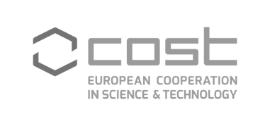

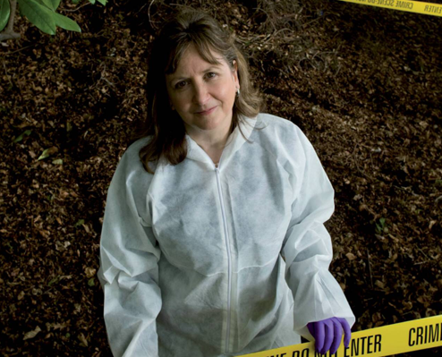
Short biography, June 2017

Professor Lorna Dawson, Head of Forensic Soil Science, James Hutton institute, Aberdeen, AB15 8QH; Knowledge Exchange Lead for Environment, SEFARI Gateway Centre for Knowledge Exchange; Visiting Professor, Forensic Science, RGU.

Lorna Dawson, BSc (Hons) (Geography, Edinburgh University), PhD (Soil Science, Aberdeen University), is head of Forensic Soil Science at the James Hutton Institute, visiting professor of Forensic Science at Robert Gordon University, a Chartered Scientist, a Fellow of the Institute of British Soil Scientists, and a Fellow of the Royal Society of Arts. She is a registered expert with the National Crime Agency, works with police forces and agencies across the UK and overseas soil trace evidence provision in search and evidence.
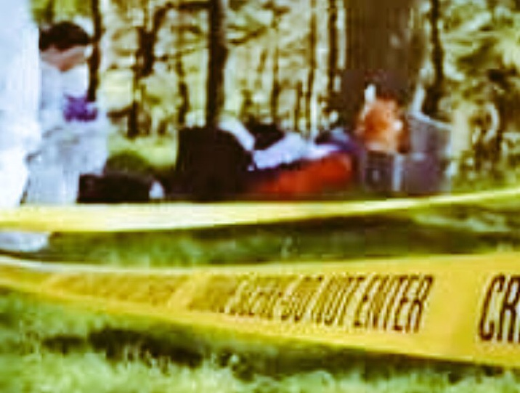

She holds diplomas in civil and criminal law (Cardiff University, 2011, 2012 and a Masterclass in Expert Witness Report writing, 2017) and regularly attends court as an expert witness. She sits on the British Association of Science General Committee, holds a diploma in Science Communication from Bristol University (2010) and is the Knowledge Exchange Lead for Enviroment for the Scottish Government SEFARI Gateway.

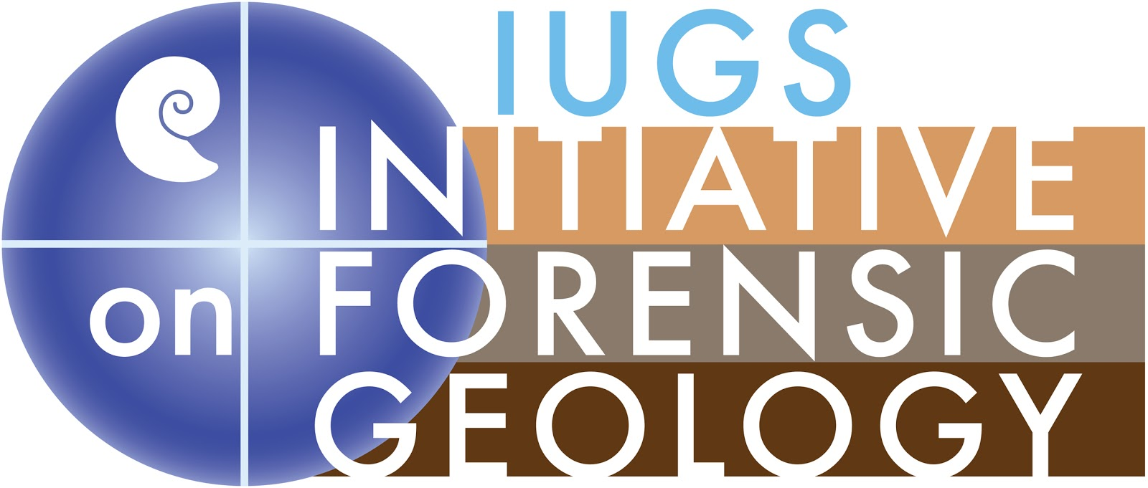


She is treasurer of the IUGS-IFG (International Union of Geological Sciences-Initiative on Forensic Geology) and regularly takes part in training police and forensic practitioners world wide. She is an advisor to the CBRN-GIFT (Generic Integrated Forensic Toolbox to investigate Chemical, Biological, RadioNuclear incidents), and is a member of the ASPT (Animals, Soil, Plant Trace) working group of the ENFSI (European Network of Forensic Science Institutes).



Lorna is a member of the COST action 16101 Multi Forensee, representing multi spectral imaging of soil for forensic use. She has acted as an expert on many high profile cases such as the search for Ben Needham, Pamela Jackson, Moira Anderson and has given evidence in many cases including R v Blakey, R v Halliwell, WA v Rayney, HMA v Pacteau, and HMA v Sinclair.


Lorna is based at the James Hutton Institute in Aberdeen, leading a team of experts in the application of soil, microbial and plant in assisting police and practitioners in both search and as trace evidence comparison. The James Hutton Institute combines strengths in crops, soils and land use and environmental research, and makes a major contribution to the understanding of key global issues, such as food, energy and environmental security, and developing and promoting effective technological and management solutions to these. The Institute is an internationally networked organisation and operates from multiple sites, including two main ones in Scotland at Aberdeen and Hi Dundee. It employs more than 500 scientists and support staff, making it one of the biggest research centres in the UK and the first of its type in Europe. The Institute is one of the Scottish Government’s main research providers in environmental, crop and food science and has a major role in the Scottish knowledge economy.



Lorna is the KE Lead for the topic of Environment for SEFARI Gateway. The SEFARI name itself – Scottish Environment, Food and Agriculture Research Institutes – includes critical work done with and for the Scottish Government under a £250m five-year research programme-the Moredun Research Institute, Scotland’s Rural College, the Rowett Institute, Biomathematics and Statistics Scotland, Royal Botanic Garden Edinburgh and the James Hutton Institute. These organisations are working together as a collective in interdisciplinary scientific research with impact. SEFARI Gateway will improve the use and impact of that research – for business, policy-makers, individuals and communities. This work will unlock the potential that exists within the Research Institutes to deliver “Leading Ideas for Better Lives”.

