
MULTIFORESEE Training School (CA16101)
Awarded Trainees 2017-2018
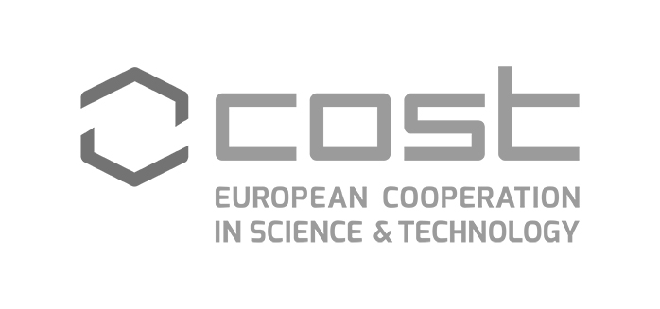

 | Name | Country | Institution
1. | Aleksandra Pawlaczyk | Poland | Lodz University of technology
2. | Elżbieta Maćkiewicz | Poland | Lodz University of technology
3. | Madalina Maria Diac | Romania | University of Medicine and Pharmacy ”Gr.T.Popa” Iași
4. | Ivana Ognjanovic | Montenegro | UNIVERSITY OF DONJA GORICA
5. | Berta Carrion-Ruiz | Spain | Polytechnic University of Valencia
6. | Michiel Vandenbosch | Belgium | KU Leuven
7. | Rebecca Brekau | Germany | BTU Cottbus-Senftenberg
8. | Darren Debattista | Malta | MALTA POLICE FORCE
9. | Ana Cristina Assis | Portugal | Polícia Judiciária
10. | Riccardo di Pietro | Italy | University of Messina

Delivered by West Yorkshire Police & Regional Scientific Support Services
Yorkshire and the Humber CSI Training Team


MULTIFORESEE Training School
Operational CSI and Imaging Techniques 21-25 Aug 2017
Location: West Yorkshire Police Training and Development Centre
Carr Gate Complex
Bradford Road
Wakefield WF2 0QD
United Kingdom
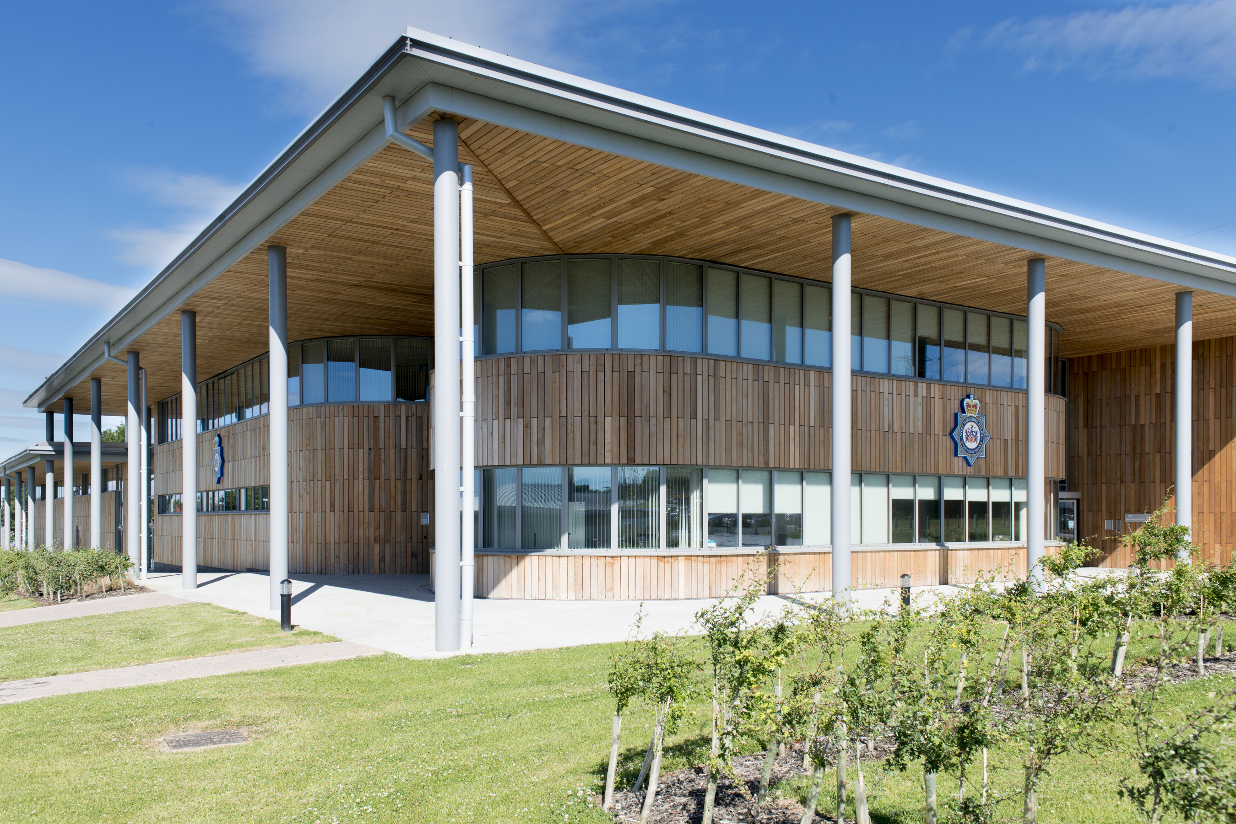

Dates: Monday 21st August to Friday 25th August 2017

** Strictly Limited Places **

